VSS Login and Printer Configuration for Thin Client Devices

(Comment on the Website: with the use of Thin Clients technology and the way that the screen shots are presented, the constant motion of the US Flags causes constant network usage which is unnecessary bandwidth utilization because of the need to constantly update the splash screen. Just a NOTE!!)

Requirements:

Thin Client device that supports printing (we are using NEOWARE 4000’s)
Line Printer to print Volunteer meal tickets (we are using “STAR sp200”)
Citrix MetaFrame environment to publish the Website Browser

Connecting the Printer to the Thin Client device

1. Connect the line printer to the COM 1 port on the Thin Client device

2. Turn the Thin Client device on and enter the SETTINGS TAB-→ APPLIANCE PROPERTIES-→ PRINTERS now make the port at which you connected the line printer to as your default, we used the COM 1 Text Only with success. (MAKE DEFAULT)

3. Power on your line printer and gather the name of your Thin Client device to use in assigning a printer port to the appropriate device later.

Publishing the Web Browser and Website

http://teamsoftware.bizland.com/downloads.html

This Web Browser is perfect (Public Web Browser v2) it comes with a configuration file to help set up the kiosk mode and take away menus that are not needed. Site License for a year is $100. This is a product that can be used for multiple things in your network.



Even with the –k switch on IE, the kiosk mode in the Public Web Browser is much easier to implement and manage than IE.

1. Once you have chosen the appropriate Web Browser (IE or PWB) then you must publish the application in the Citrix Management Console.

2. Browse and find the appropriate executable to publish and use quotes to add the Website to the published Web Browser, like so….

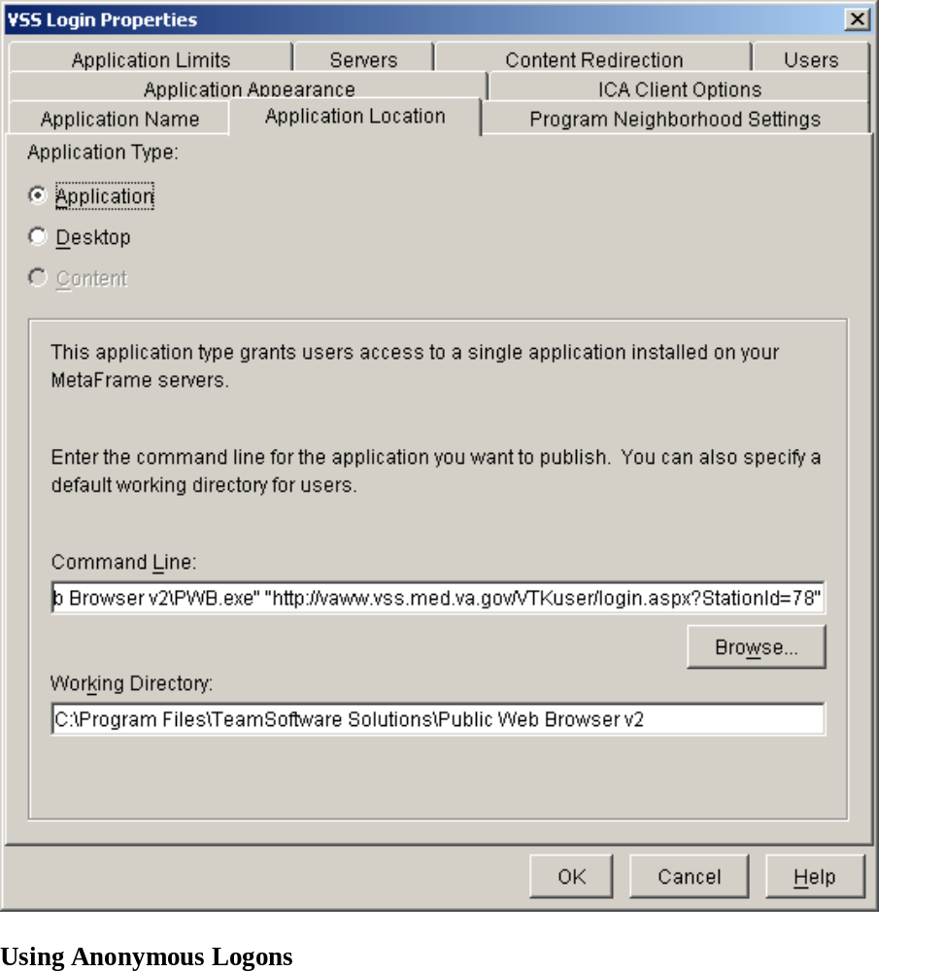

3. Just be sure you point to the website through the Citrix Management Console, like illustrated above using the quotes, instead of through the configuration files homepage. (Reasoning: to use the web browser for other reasons without always pointing to the VSS Login website)

4. Now that the website should be published, it is time to test it out.

Installing and Configuring the Line Printer (SP200)

1. First thing is to go to the website http://www.starmicronics.com/ and migrate to the receipt and kiosk printers-→ product support (drivers)-→ Windows 2000 and XP software (LineMode_2K_XP)-→ Download Software-→Product SP200

2. Now that you have the software, download and install on the server that will be hosting the application you published on.

3. You will get to this screen, make sure all the parameters are set and choose the Star SP212 Model and Port COM1 and then with everything set HIT: ‘Extract files for installation via Windows Add Printer Wizard’

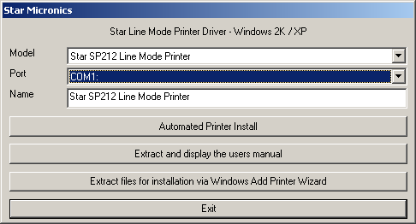

4. Now you should see this, just hit YES.

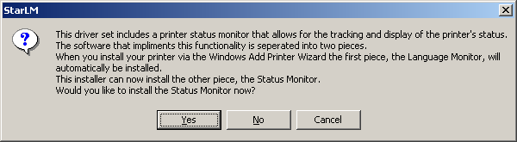

5. Now go to your Add Printer and navigate through like you are adding local printer, just keep hitting Next until you come to the Printer selection screen and Choose HAVE DISK.

6. Navigate to where the STAR software was installed (I believe by default it is on the Desktop) and select the oemprint driver and then choose the brand of printer you have and select Next.
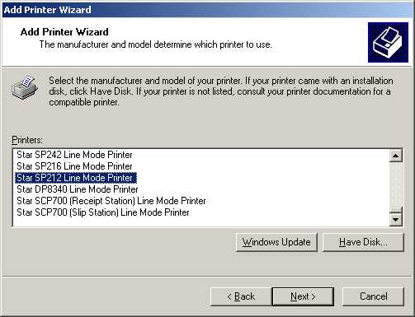

7. Just NEXT through the selections and FINISH. (NOTE: you may want to name the printer in case of multiple sites or locations.

8. The Printer should now be attached to the Browser for Meal Ticket Printing. You may want to confirm the settings through the printer properties. This is where you may need the name of the Thin Client device to attach to the appropriate port.

9. You will also have to set up the printer Page Setup: as follows

Paper Size-66x254mm
Margins: Left:0.1 Right:0.1 Top:0.5 Bottom: 0.75
No header or footer.
Source: Auto

ANY QUESTIONS:

Contact: Val Wearing at VA Connecticut (Software) 203 932 5711 ext 5081
Valerie.Wearing@med.va.gov

Contact: Jamey Milner at VA Connecticut (Hardware) 203 932 5711 ext 4692
Jamey.Milner@med.va.gov

